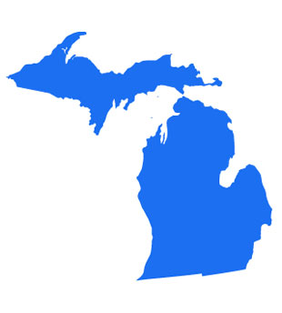

VOLUME 50 SPRING 2011 ISSUE 1

Fall Meeting

October 13-14-15th



President

Sieglinde Wildie MLT
25 Rural St.
Port Huron, MI 48060
H- 810-982-5651
W- 810-985-1525
Ext. 2438

Vice President
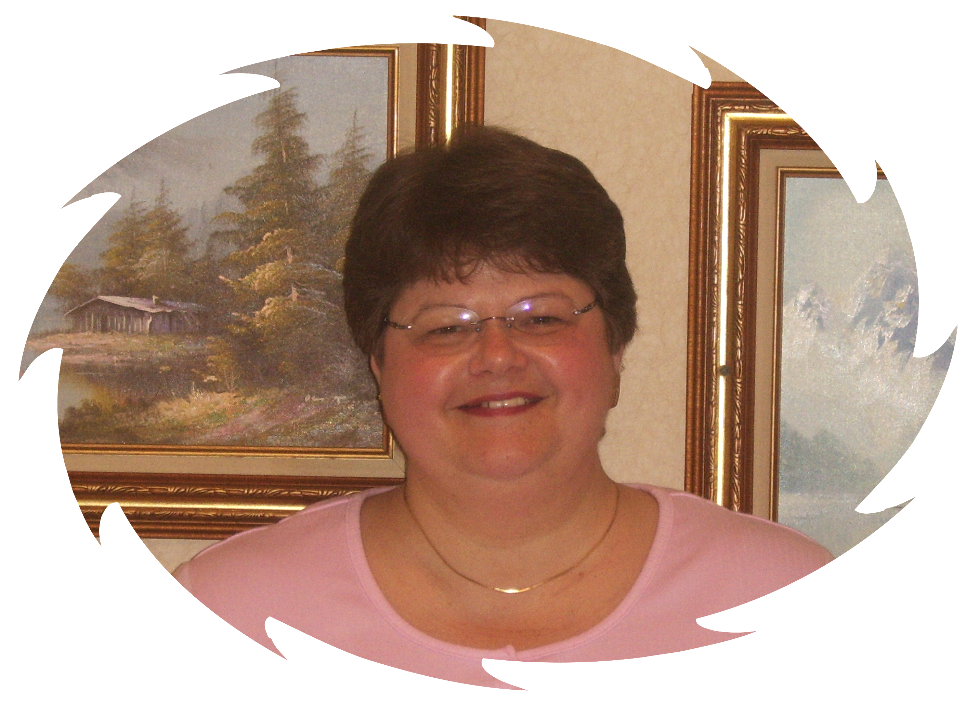
Linda Ruggles RMA
2435 Elm Road
Hudson, MI 49247
H-517-547-4081

Secretary

Nathalie Dixon MT
3358 Dale Road
Saginaw, MI 48603
H- 989-799-1664

Treasurer

Suellen Schobert MLT
1516 North Carolina
Saginaw, MI 48602
H- 989-793-6935

District Councillor
Clara Boykin MT
1023 Dayton Ave.
St. Paul, MN 55104
H- 651- 644-3128
W – 651- 647-2220

Board Members
Carol Cartwright RMA
982 M-68
Afton, MI 49705

Patricia Dare RMA
PO Box 120
Hamburg, MI 48139
H-810-231-0637

Webb Gray MT
27494 Mayfair Ave
Brownstown, MI 48183-4815
H-734-692-5902

Debra Herrst RMA
11600 Seitz Dr.
Dexter, MI 48130-9787
H-734-475-8857

Rebecca Jackson AHI
621 Waldman Ave.
Flint, MI 48507
H-810-234-4564

Carolyn Spear, MT
939 Major Street
Flint, MI 48507-2364
H-810-234-0966

Loretta Sweet MT
8165 Lakeshore
Lakeport, MI 48059
H-810-327-6847

Nancy Winslow RMA
9491 Waite Dr.
Fenton, MI 48430

MSSAMT WEBPAGE
http://mssamt.tripod.com
MSSAMT EMAIL

MSSAMT@YAHOO.COM

Table of Contents:
Board Members | 1
Table of Contents | 2
President’s Message | 3
District Councillor’s  Message | 4
Editor’s Message | 5
Welcome  New Members | 6-10
Member Anniversaries | 11
In The News –  Measles Outbreak | 12-13
AMT Convention 2011 | 14

American Medical Technologists
10700 West Higgins Road
Rosemont, IL 60018
800-275-1268/847-823-5169
Fax 847-823-0458
E-mail: mail@AMT1.com
Judiciary Councillor
Kim Cheuvront, PhD
100 Fair Oaks Dr.
Fairmont, WV 26554

MSSAMT MICROBE

Advertising Rates Per Issue
Business Card $30.00
One Half Page $60.00
One Full Page $100.00
Money received for advertising will be used to help publish the MICROBE. Checks are to be written to MSSAMT. Information for publication should be submitted to the Editor.
PUBLICATION DATES:
FIRST ISSUE…….MAY/JUNE
SECOND ISSUE…NOV/DEC

The Microbe is a publication of the Michigan State Society of American Medical Technologists and is published two (2) times a year.

The views and opinions expressed herein are those of the contributors and do not necessarily reflect the opinions of the MSSAMT or American Medial Technologists. The Editor reserves the right to accept, reject or revise any material submitted for publication.


Make sure to send amt a change of address.

Do not get lost!

We cannot communicate if we do not know where you are

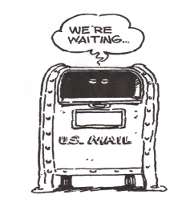
Please include your
Email address



President’s Message…

Hello My Fellow Members,

I hope so far every state society member has had satisfactory year. It is hard to believe, but half of the New Year has already passed.

Recently, we had our state board meeting and finalized our delegate list. Eight delegates will represent our state society at the national convention in Miami, Florida. But we always have room for more. If you are considering joining our delegates, please call me at 1-810-982-5651 and I will add your name to the list. At the national convention one of our long time and very loyal members, Loretta Sweet will receive the “Silver Award”. “What an Honor!” Also our Michigan State Society will receive the “State Honor Roll Award”, for the 13th year straight.

Some of our board members will meet in Lansing and see if Senator Jim Marleau (Chair of the Health Policy Committee) will talk to us regarding reintroducing the state licensor bill for Laboratory personnel.

Our State Scientific meeting is fast approaching, October 13-14-15, 2011. I would love to see you in Frankenmuth. As you know our speakers and lecturers are worth coming to hear, getting the CECs and enjoying the good food and a little sightseeing is like a “Win – Win” situation.

Until then, I wish every state society member and their families a great and safe summer.

Sincerely,
Sieglinde Wildie MLT

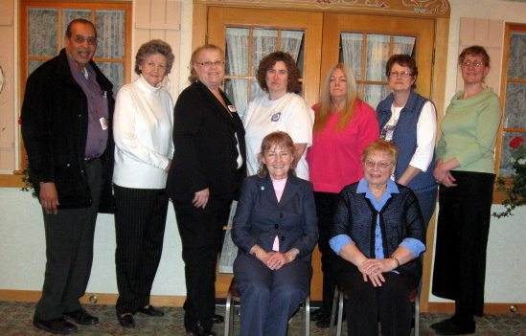

Spring Board Meeting April 2011 Frankenmuth

Great Lakes District
Councilor’s Message…

Warm Greetings to the members of the Great Lakes District:

We are happy to announce the appointment of Nancy Gabl, (Illinois) as the new Publication Chair. Congratulations are also in order for the newly Tri State Society of Connecticut, Massachusetts and Rhode Island.

Remember the professional group celebrations that are coming up. National Dental Assistants Week, March 6-12, 2011 and National Medical Lab Week, April 24-30, 2011.

The 11 States that are participating in the new banking pilot will take affect in April 2011 with the rebate checks that will be issued. Look for more information to follow.

Our National Meeting this year will be in Miami, Florida, August 1-6, 2011 at the Intercontinental Hotel, 100 Chopin Plaza, phone number 305-577-1000. The website for the hotel is www.icmamihotel.com .

Change is happening in AMT, come to our Leadership Training Session during the National Meeting for more information. Registration for the National meeting is available online and very easy to navigate. When checking into hotel try to use your credit card vs. a debit card for incidentals. There will be discounts for parking at the hotel but you must do valet parking. Cookbooks will be available for sale at the National Meeting.

Remember you are responsible for your tracking of your CE credits by our system that we have in place AMTRAX.

Remember to keep watch in your states for any legislation that will have any on our members. The next National Meeting will be in San Antonio, Texas. More information to follow.

My challenge to all members, please get involve with your state society, embrace leadership and mentor all new members.

If I can assist you in any way please don’t hesitate to contact me.

Clara Boykin, MT

District Councilor Great Lakes
1023 Dayton Avenue
St. Paul, Minnesota 55104
Email: claraboykin1023@msn.com
Work - 651 999 4788 (Monday thru Friday)
Cell - 651 247 3231 Home - 651 644 3128

Editor’s Message ……


As we start another year in our beautiful state of Michigan I am reminded of what my grandmother would tell me each spring, it’s Michigan if you don’t like the weather just wait a minute; it will change soon. We had a record wet spring and definitely a cold one but now we are straight into summer and 90 degree temperatures.

As of this issue MSSAMT is welcoming 458 new members to our ranks, we have well over 2000 members and present and are adding more everyday. It is so great to see our numbers grow like this.

All current new members, schools and hospitals in Michigan and members who have let me know that they prefer a printed copy of the Microbe will receive this issue in the mail where as the majority of our members will go to our website to read this and past issues of the Microbe. This has saved us a lot of money that we can use towards our fall meeting in Frankenmuth. As usual, the lectures are going to be great.

Unfortunately last fall, James Van Rhee had to cancel his Hematology lecture due to illness but he will be attending this fall and will present this lecture. We all look forward to his presentations. He is our favorite speaker and last fall was the first time he has missed our meeting in over 10 years.

Eight of us will be heading to Miami to the National Convention, which is a Joint Meeting with CASMET this year. These joint meetings are always very special; if you wish to join us as a delegate please contact our president Sieglinde to signup.

If you have any items you wish to see in the Microbe or on the website please let us know at mssamt@yahoo.com and we will do our best to respond to your requests.

Until October, have a very pleasant summer and look for info on the fall meeting on the website and in your mailbox in September.

Suellen Schobert, MLT
MSSAMT Editor

MICHIGAN STATE SOCIETY
AMERICAN MEDICAL TECHNOLOGISTS

AHI |  |  | MLT
Jennifer | Sater |  | Catherine | Kay
 |  |  | Vaishali | Patel
MT |  |  | RDA
Bethany | Biallas |  | Terrie | Annis
Roselle | Crisostomo |  | Noreen | Bishsoff
Kadhum | Swailem |  | Edith | Dawson
 |  |  | Maria | Diaz
 |  |  | Adell | Lee
 |  |  | Christine | McCauley
 |  |  | Reginald | Reid
 |  |  | Regina | Worley
CMAS
Diana | Beaman |  | Lauretta | Brown
Jessica | Bush |  | Nicolette | Campbell
Dawn | Cope |  | Donald | Cross
Rebecca | Dawson |  | Nicole | Donald
Christina | Elsass |  | Jamie | Ewing
Janet | Fleischer |  | Starr | Godwin
Josette | Gonzales |  | David | Griggs
Shawndra | Harris |  | Joyce | Hathaway
Mark | Heath |  | Lisa | Heinritz
Sheila | Hite |  | Krystal | Inman
Sheila | Kniffin |  | Amanda | Lilly
Choncha | Marshall |  | Vanessa | McMath
Victoria | Moore |  | Julie | Oexler
Tiffany | Pettway |  | Meri | Phelps
Dawn | Porter |  | Judy | Rabbitt
Kelly | Ryan |  | Linda | Scott
Kristi | Searles |  | Teneille | Smith
Windy | Spencer |  | Jennifer | Symons
Shannon | Teems |  | Elizabeth | Trevino
Janet | Turk |  | Doreen | Van Winkle
Melissa | Wilson |  | Victoria | Wright
Tonya | Yinger
RMA
Aisha | Adekunle |  | Victoria | Adkins
Maruop | Agany |  | Robert | Aldridge
Amanda | Alvarez |  | Asheley | Ampey
Rachel | Anderson |  | Amber | Angel

New Members Continued
RMAs

Jimmie | Armes |  |  |  | Sandra | Armes
Sandra | Armijo |  |  |  | Stacey | Askew
Wendy | Bailey |  |  |  | Destiny | Banks
Amanda | Barajas-Espinoza |  |  |  | Joy | Barber
Amanda | Barker |  |  |  | Kathleen | Barton
Stephanie | Bates |  |  |  | April | Bates-Wilbur
Amber | Battle |  |  |  | Angela Marie | Bell
Jessica | Bell |  |  |  | Heidi | Bemis
Raquel | Benavidez |  |  |  | Lachiya | Bernard-Winston
Sherilyn | Bielas |  |  |  | Nicole | Bisson
Aaron | Bloomfield |  |  |  | Nickolas | Bloss
Charity | Blum |  |  |  | Maryann | Bock
Carol | Borgerding |  |  |  | Lauri | Borst
Ashley | Boswell |  |  |  | Jessica | Bowker
Renae | Boyer |  |  |  | Jason | Bradford
Marybeth | Brewer |  |  |  | Colette | Brown
Jordan | Brown |  |  |  | Leslie | Brown
Nathan | Brown |  |  |  | Shawna | Brubaker
Melissa | Buckenberger |  |  |  | Cynthia | Burton
Brandy | Bush |  |  |  | Ebony | Bush
Amanda | Buttrey |  |  |  | Felisia | Byrd
Darcy | Byron |  |  |  | Lisa | Caldwell
Bonnie | Callender |  |  |  | Sierra | Canady
Stacy | Cantwell |  |  |  | Dawn | Carter
Kasey | Carter |  |  |  | Casey | Cash
Heather | Castor |  |  |  | Shauna | Chambers
Delisa | Chandler |  |  |  | Seneika | Chapman
Britney | Chappell |  |  |  | Kiyuana | Chappell
Amanda | Chavis |  |  |  | Sylvia | Cheney
Breiann | Church |  |  |  | Carolyn | Ciantar
Jennifer | Clark |  |  |  | Kathy | Clore
Susan | Colegrove |  |  |  | Kim | Collier
Maria | Colpaert |  |  |  | Amanda | Cook
Kara | Cook |  |  |  | Kimberly | Cotton
Lindsey | Craddock |  |  |  | Whitney | Cromwell
Virginia | Cross |  |  |  | Barbara | Crowder
Margaret | Cummins |  |  |  | Cynthia | Cunningham
Sheila | Cusson |  |  |  | Bambi | D Ambrose
Kimberly | Dale |  |  |  | Jessica | Daniels
Sarah | Daugherty |  |  |  | Angela | Davis
Deion | Davis |  |  |  | Dominique | Davis
Marcia | Davis |  |  |  | Lori | De Young
Kari | Deeds |  |  |  | Mary | Degiulio
Kevin | Deming |  |  |  | Evady | Demson
Denise | Denison |  |  |  | Delia | Dickerson
Amanda | Diethrich |  |  |  | Rebecca | Dilday
Marquetta | Dixon |  |  |  | Patricia | Dooley
Jessica | Doornhaag |  |  |  | Amy | Dowd
Angela | Downard |  |  |  | Casey | Drumheller
Nicole | Duling |  |  |  | Dujuana | Dunbar
Emily | Dunham |  |  |  | Christina | Dunn
Leslie | Durham |  |  |  | Kerry | Dutcher
Jessica | Dye |  |  |  | Carmen | Earl
Julia | Ebsch |  |  |  | Christina | Erickson
Kelli | Ferrier |  |  |  | Alice | Fillip
Ileeyia | Fisher |  |  |  | Precious | Fisher
Shevia | Foster |  |  |  | Tiffany | Foutner
Jennifer | Funni |  |  |  | Kristopher | Gallas
Rhonda | Garrett |  |  |  | Elizabeth | Gazda
Jessica | Gerdau |  |  |  | Michelle | Gibson
Patricia | Gibson |  |  |  | Dayna | Gipson
Stephanie | Glenn |  |  |  | Brian | Gorkiewicz
Monica | Greenman |  |  |  | Sarah | Gutzke
Rachel | Hackworth |  |  |  | Lynn | Hang
Nakita | Harden |  |  |  | Kelly | Hargrove
Joshua | Harman |  |  |  | Shannon | Harmon
Robert | Harrison |  |  |  | Kelli | Heeney
Jason | Herington |  |  |  | Dana | Hertzfeld
Samantha | Hickman |  |  |  | Amber | Hicks
Jennifer | Hicks |  |  |  | Daisha | Hill
Jennifer | Hinkle |  |  |  | Heather | Holmes
Donnette | Holton |  |  |  | Amanda | Hopkins
Jessica | Hopkins |  |  |  | Julie | Howard
Kala | Jackson |  |  |  | Jacqueline | Jenkins
Mary Jo | Jobbitt |  |  |  | Courtney | Johnson
Kandance | Johnson |  |  |  | Anise | Jones
Ashley | Jones |  |  |  | Cathlene | Jones
June | Jones |  |  |  | Tiffany | Jones
Karen | Kaltz |  |  |  | Anne | Kaniclides
Kelly | Kelly |  |  |  | Josette | Kennedy
Lynda | King |  |  |  | Geralyn | Kinsman
Alisha | Kloska |  |  |  | Sherman | Kniss
Lauren | Kraker |  |  |  | Jessica | Krukowski
Michelle | Kuchar |  |  |  | Ran | Kudo
Elizabeth | Lacey |  |  |  | Allie | Lake
Jennifer | Landfair |  |  |  | Ashley | Langdon
Matthew | Langley |  |  |  | Kevin | Lawson
Linda | Le Monde |  |  |  | Nitita | Lee
Megan | Leeder |  |  |  | Lori | Leidner
Robin | Leitch |  |  |  | Deborah | Lentini
Natasha | Lerch |  |  |  | Angillesha | Lewis
Liza | Lindeman |  |  |  | Bonita | Lloyd
Ronda | Lockwood |  |  |  | Deborah | Logan
Anna | Lucio |  |  |  | Marie | Mack
Amanda | Mann |  |  |  | Melissa | Mann
Elsie | Mares |  |  |  | Rachel | Marl
Enrique | Martinez |  |  |  | Jamie | Martinez
Patricia | Mata |  |  |  | Kimberly | Mathews
Kathleen | Mattis |  |  |  | Vicki | Mazure
Emily | Mc Comb |  |  |  | Stacey | Mc Cormack
Brittany | Mc Cranie |  |  |  | Penny | Mc Mann
Melissa | Mc Millon |  |  |  | Cari | Mc Pherson
Angelissa | Mckenzie |  |  |  | Jimmy | Meade
Jennifer | Meadows |  |  |  | Amanda | Meinema
Mary | Michalak |  |  |  | Jordyn | Mickens
Erin | Miller |  |  |  | Rachael | Miller
Maria | Milliken |  |  |  | Chavon | Mitchell
Zachary | Mohney |  |  |  | Jeffrey | Molzan
Nicole | Monroe |  |  |  | Karen | Montagano
Christina | Moore |  |  |  | Jacklyn | Moore
Larry | Moore |  |  |  | Flor | Moreno-Gonzalez
Melissa | Muncy |  |  |  | Ashley | Napieralski
Carmen | Ofarrell |  |  |  | Kerri | Oisten
Justine | Omo |  |  |  | Tammi | Oroshi
Marijo | Orzechowski |  |  |  | Kimberly | Ostrander
Collin | Oswald |  |  |  | Denise | Oudekerk
Amy | Outman |  |  |  | Kicole | Owens
Amy | Pagels |  |  |  | Stefanie | Palermo
Amber | Palmatier |  |  |  | Amari | Palmer
Michelle | Parsons |  |  |  | Marlene | Payne
Tania | Peete |  |  |  | Sharon | Perry
Joyce | Pigeon |  |  |  | Crystal | Pilz
James | Pitts |  |  |  | Michelle | Platek
Jessica | Pluff |  |  |  | Michelle | Pope
Mary | Prather |  |  |  | Rachel | Price
Karen | Pulido |  |  |  | Brittany | Ranes
Roland | Rawson |  |  |  | Tiffany | Ray
Dawn | Reed |  |  |  | Sara | Reeves
Richard | Regenold |  |  |  | Cina | Reyes-Garay
Macy | Ries |  |  |  | Carrie | Riker
Christine | Roberts |  |  |  | Jenny | Roberts-Day
Echo | Robertson |  |  |  | Crystal | Robinson
Thomas | Robinson |  |  |  | Dawn | Roper
Diane | Rork |  |  |  | Ashley | Rose
Jennifer | Rosenburg |  |  |  | Candice | Ross
Patrice | Ross |  |  |  | Veronica | Ross
Janella | Rucker |  |  |  | Anne | Ruddick
Nicole | Rumery |  |  |  | Amanda | Sanders
Kayla | Sawyer |  |  |  | Glenda | Schmidt
Sharolyn | Schmidt |  |  |  | Melinda | Schroeder
Jodi | Schuler |  |  |  | Bradford | Schwaiger
Denise | Schewartz |  |  |  | Jaclyn | Schwartz
Jennifer | Scott |  |  |  | Debra | Skinner-Clos
Eugene | Slater |  |  |  | Danielle | Small
Amandy | Smith |  |  |  | Brian | Smith
Cassandra | Smith |  |  |  | Deborah | Smith
Sarah | Smith |  |  |  | Stephanie | Smith
Tammy | Soumah |  |  |  | Vail | Southorn
Alyssia | Spees |  |  |  | Morgan | Stanton
Samantha | Starin |  |  | Nichole |  | Starnes
Mary | Steinman |  |  | Gregory |  | Stiles
Kate | Stoddard |  |  | Kim |  | Sullivan
Tanya | Svihl |  |  | Michelle |  | Swank
Kari | Swiben |  |  | Kimberley |  | Swinehart
Faynicia | Taylor |  |  | Gregory |  | Taylor
William | Tefft |  |  | Amanda |  | Terry
Angela | Terry |  |  | Ronda |  | Terry
Gina | Thelmas |  |  | Marlene |  | Thompson
Amanda | Timko |  |  | Angie |  | Torrens
Danielle | Triemstra |  |  | Nickcole |  | Trudeau
Carrie | Tyler |  |  | Cindy |  | Underwood
Steven | Underwood |  |  | Rachel |  | Urbon
Carrie | Vallade |  |  | Rebekah |  | Van Epps
Molly | Van Horn |  |  | Jodie |  | Vist
Anthony | Vollmer |  |  | Renee |  | Vos
Kashi | Wade |  |  | Alex |  | Walker
Jennifer | Ward |  |  | Sarah |  | Warner
Hope | Warren |  |  | Tisha |  | Washington
Jennifer | Wasinski |  |  | Sarah |  | Wasper
Arthuria | Watkins |  |  | Tiffany |  | Weick
Heather | Weiman |  |  | Kelly |  | Wells
Jennifer | Wesner |  |  | Greta |  | Wheaton
Krystal | White |  |  | Destiny |  | Whitley
Jessica | Whitney |  |  | Kathleen |  | Wielinga
Timika | Wilcox |  |  | Heather |  | Wilkinson
Lonnette | Williams |  |  | Tanya |  | Williams
Trinity | Williams |  |  | Amy |  | Wilson
Blake | Wilson |  |  | Delana |  | Wilson
Jackie | Wilson |  |  | Jessica |  | Winfrey
Carrie Ann | Wingaie |  |  | Alexandria |  | Winters
Amanda | Wixon |  |  | Jennette |  | Wolf
Jamie | Wolfrom |  |  | Kimberly |  | Wolownik
Loretta | Woods |  |  | Cheryl |  | Woodward
Nicole | Woodward |  |  | Renee |  | Wrather
Katrina | Wright |  |  | Troy |  | Wyatt
Lawrence | Wynn |  |  | Brooklyn |  | York
Natasha | Yorks |  |  | Lillian |  | Zaldivar
Stephainie | Ziarko |  |  | Marija |  | Zurevska
Jami | Zybach

RPT
Jennifer | Breneman |  |  | Annabel | Carter
Melanie | Carter |  |  | Elizabeth | Castillo
Vera | Claybrooks |  |  | Bobbi | Dansard
Tiffany | Doxie |  |  | Tyhnette | Fenn
Karen | Glab |  |  | Julie | Hornyak
Kathryn | Marry |  |  | Natasha | Mincey
Mary | Omo |  |  | Mari Grace | Rodgriguez
Jamie | Tubb |  |  | Marquita | Walker

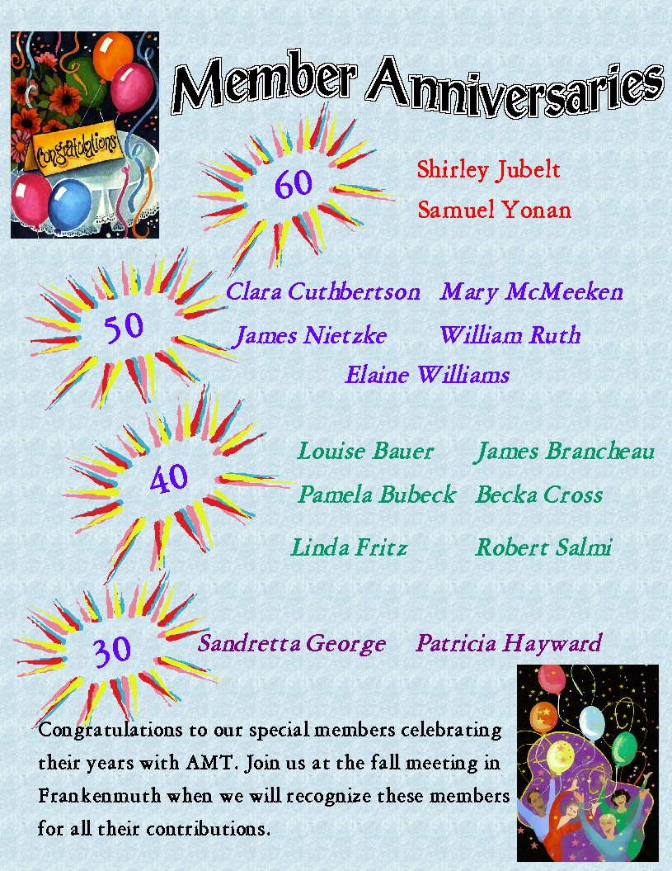

In the News

Measles Outbreak 2011

This year is starting to look like the worst year for measles cases in more than a decade. Though mostly eliminated from the US in the early 2000’s, in May the Center for Disease Control [CDC] reported the most cases of measles since 1996.

In the first 19 weeks of this year, 118 cases in 23 states have been reported, compared to an average of 56 cases a year between 2001 and 2008. There has been in five months more than double the number of cases that normally occur in an entire year.

Most cases are imported into the US by travelers who have visited countries with outbreaks, then brought the infection home, sometimes spreading it to others. In Europe, 38 countries have reported cases. In France nearly 10,000 cases were reported in the first four months of 2011. In Africa; Nigeria has had 29,871 suspected cases in 2011, 122 deaths as of April 22, 2011 with the state of Bauchi most affected with 17,300 cases. The Democratic Republic of Congo has reported more than 16,000 suspected cases and 107 deaths in January and February.

Travelers to Europe, Africa and Asia have been sources of imported cases in the US. Particular hotspots may come and go, but all travelers should protect themselves by being vaccinated.

Up to 90% of unvaccinated people who are exposed to the measles virus fall ill. People with the virus harbor it in the mucus of their nose and throat and spread it through airborne droplets when they cough, sneeze or talk. The virus remains contagious for two hours in the air or on contaminated surfaces and may be picked up long after the infected person has left the area.

Up to 20 percent of measles patients suffer complications; ranging from ear infection to bronchitis, pneumonia, laryngitis and encephalitis. One in 1000 measles suffers is stricken with encephalitis and one in 1000 of these dies.

In pregnant women, measles can trigger miscarriage or preterm birth. Unlike German measles (rubella) regular measles isn’t linked to birth defects.

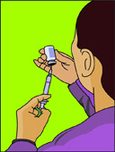
The CDC recommends vaccinating children with the first dose of MMR [measles, mumps and rubella] vaccine at the age of 12 to 15 months of age, followed by a second dose at ages 4 to 6. The vaccine is more than 95 percent effective and saves lives. Before it was available 3 to 4 million Americans came down with measles annually, of whom 400 to 500 dies, 48,000 were hospitalized and 1000 were chronically disabled from encephalitis. In countries where vaccine isn’t available the diseased killed 242,000 people, many children, in 2006.

The CDC advises that adults get MMR shot if they weren’t previously vaccinated with the two doses and attend college, work in a medical facility, travel internationally or are women of childbearing age.

You do not need the vaccine if:

- You were born before 1957

- Blood tests show that you are immune to measles, mumps and rubella

- You already had tow doses of MMR vaccine or one dose of MMR plus a second dose of the measles vaccine or you had one dose of the MMR and are at low risk for measles exposure.

Measles Quick Facts for Health Care Providers

Measles Infectious Period
From four days before rash onset through four days after rash onset.

Measles Exposure
Sharing the same airspace with a person infectious with measles (during the 4 days prior through 4 days after the rash onset) or were in the area up to 2 hours after the infectious person was present.

No minimum time period has been established for exposure, but it is presumed that the longer exposures are more likely to result in measles transmission than brief transient exposures.

Measles Incubation Period
Prodromal symptoms typically begin 8-12 days after exposure (day 0) and rash onset is typically 14 days (range 7-21 days) after exposure.

Measles Clinical Case Definition
- A generalized rash lasting >3 days; and

- A temperature >101º F (> 38.3ºC); and

- Cough, coryza, or conjunctivitis.

Measles Laboratory criteria for diagnosis
- Positive serologic test for serum measles IgM antibody; or
- Significant rise in serum measles IgG antibody between acute and convalescent titers; or
- Isolation of measles virus; or
- Detection of viral RNA by reverse transcription polymerase chain reaction (RT-PCR)

Immunity to Measles
Non high-risk people can be presumed to be immune to measles for the purposes of measles case investigations if they:

- Were born prior to 1957
- Have written documentation with dates of receipt of at least one dose of measles-containing vaccine given on or after the first birthday.
- Have a documented positive IgG test to measles; or
- Are <3 months of age and biological mother has documentation of 2 doses of MMR or is IgG positive; or
- Have history of physician diagnosed measles; or
- Served in the U.S. armed forces; or
- Entered the U.S. in 1996 or later with an immigrant visa or have a green card.

Post exposure prophylaxis
- MMR maybe given <72 hours of exposure to persons >12 months of age with 1 or no documented doses of MMR, if not contraindicated.
- Immune globulin (IG) may be given to exposed susceptible people of any age <6 days of exposure
Home quarantine
Exposed people should be instructed to isolate themselves and notify their local health department immediately if symptoms occur.
References:

Centers for Disease Control and Prevention (CDC)

National Center for Emerging and Zoonotic Infectious Diseases (NCEZID)

Division of Global Migration and Quarantine (DGMQ)

California Dept. of Public Health – May 2011 Measles Investigation Quick sheet

Healthline.com

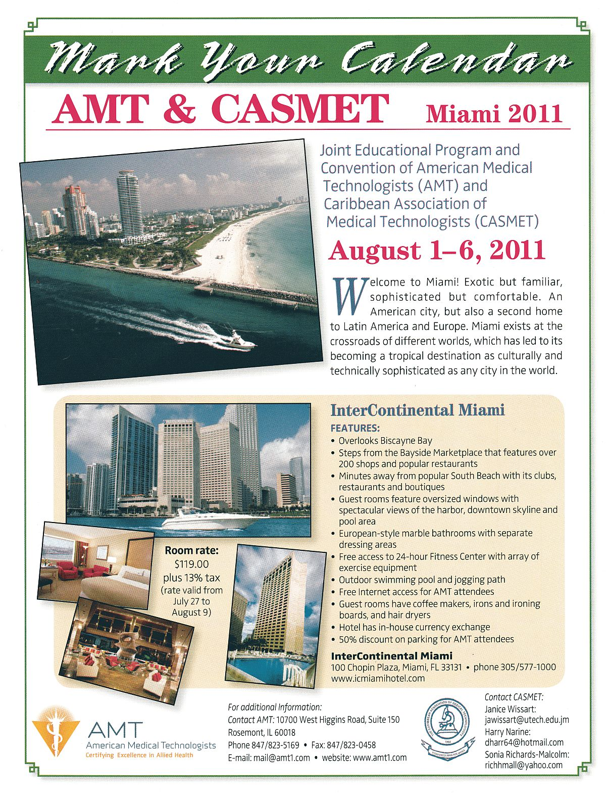

Upcoming Events:
AMT Educational Program and National Meeting:

Joint AMT and CASMET Educational Program and National Meeting:
Miami, Florida - August 1 - 6, 2011
Intercontinental Miami

MSSAMT Fall Scientific Meeting – October 13, 14, 15, 2011
Bavarian Inn Restaurant
Frankenmuth, MI
Medical Assistants Week – October 17 –21, 2011

MSSAMT MICROBE
Suellen L. Schobert MLT
1516 North Carolina
Saginaw, MI 48602-3910
PRESORTED STANDARD
U.S. POSTAGE

PAID
SAGINAW, MI 48602
PERMIT NO. 248

